SSH Connectivity to Charter Bit bucket

|  |  |  |  |
| --- | --- | --- | --- |
| Version | Author | Date | Remarks |
| 0.1 | Atul Gogte | 10thNov 2016 | initial draft version |
| 1.0 | Atul Gogte | 16th Nov 2016 | Baselined after validating procedure on few more machines. |

Step 1 – Software’s to download/install

**Charter Shared Drive**

X:\Automation\Z-atul\Softwares

**Internet**

<https://sourceforge.net/projects/sshwindows/>

<https://git-scm.com/downloads>

Install Openssh

Install Git GUI

Step 2 – Create a RSA Key Pair

Open command window and travel to bin directory under openssh

Execute **ssh-keygen –t rsa** command

For file prompt, just press enter

For passphrase prompt, just press enter

For passphrase confirmation prompt, again press enter

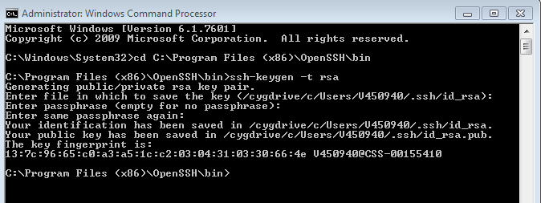

After successfully generating the key pair, you will see 2 files created (id_rsa & id_rsa.pub) under the .ssh folder of user home directory. These are your SSH private (id_rsa) & SSH public (id_rsa.pub) keys specific to your machine.

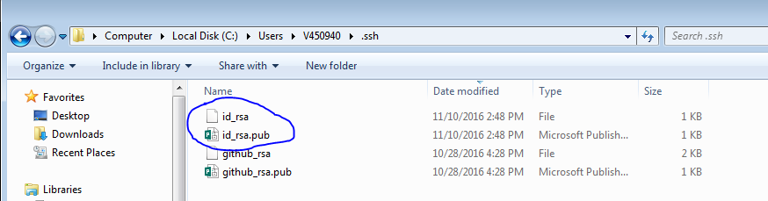

Step 3 – Add SSH key to your bit bucket profile.

Open the id_rsa.pub file using notepad and copy the content of the file.

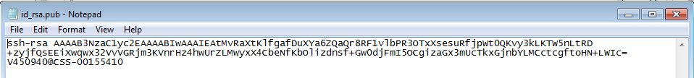

Login to bit bucket server using your PID / Charter domain password.

Go to **Manage Account** option under your bit bucket user icon on top right corner.

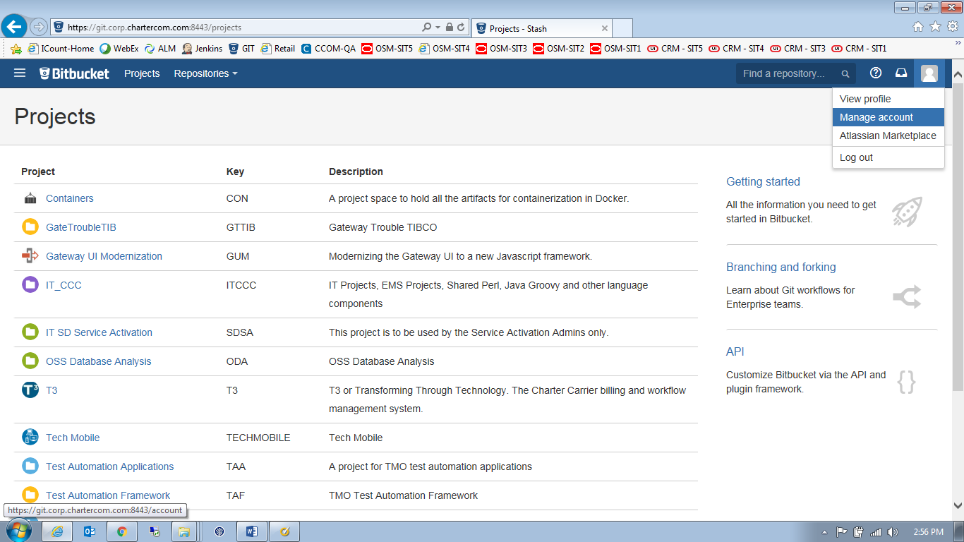

Click on **SSH keys** option and then click on **Add Key** button.

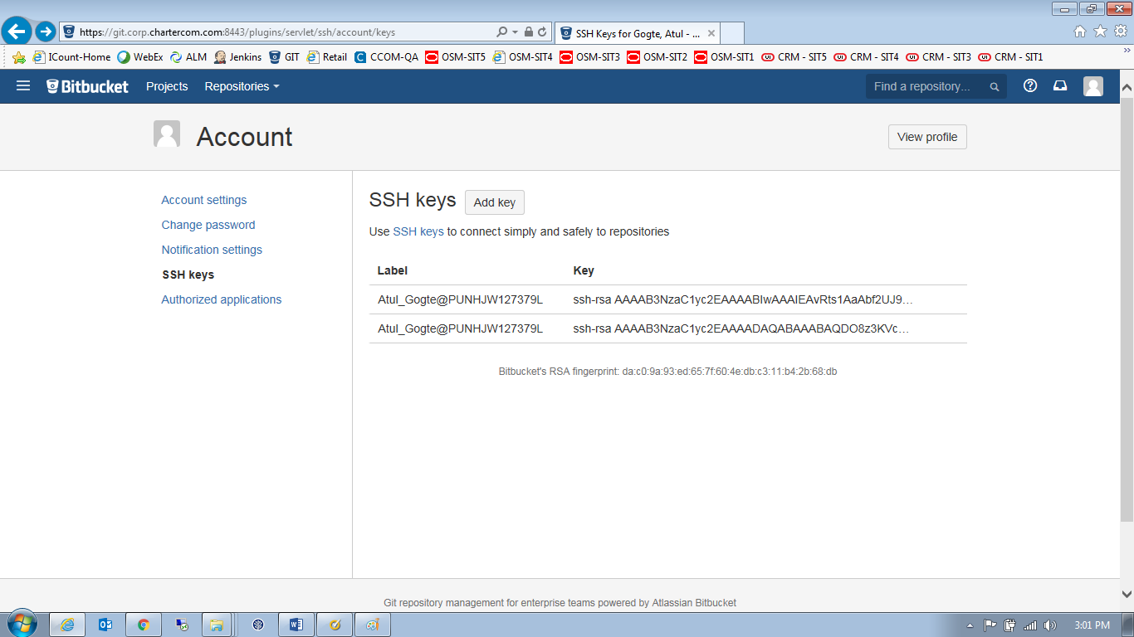

Paste the content of id_rsa.pub file from notepad into key text field and click on **Add Key** button

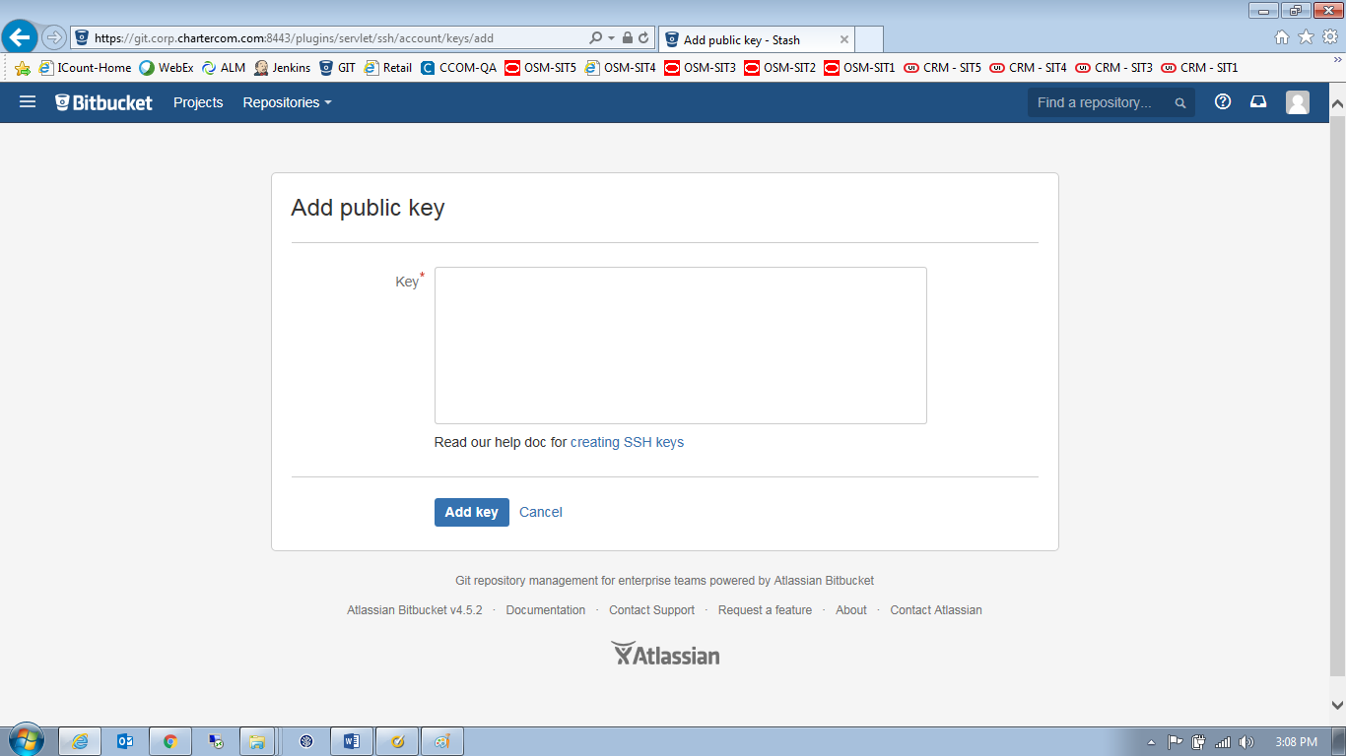

Verify that your key being successfully added to your profile

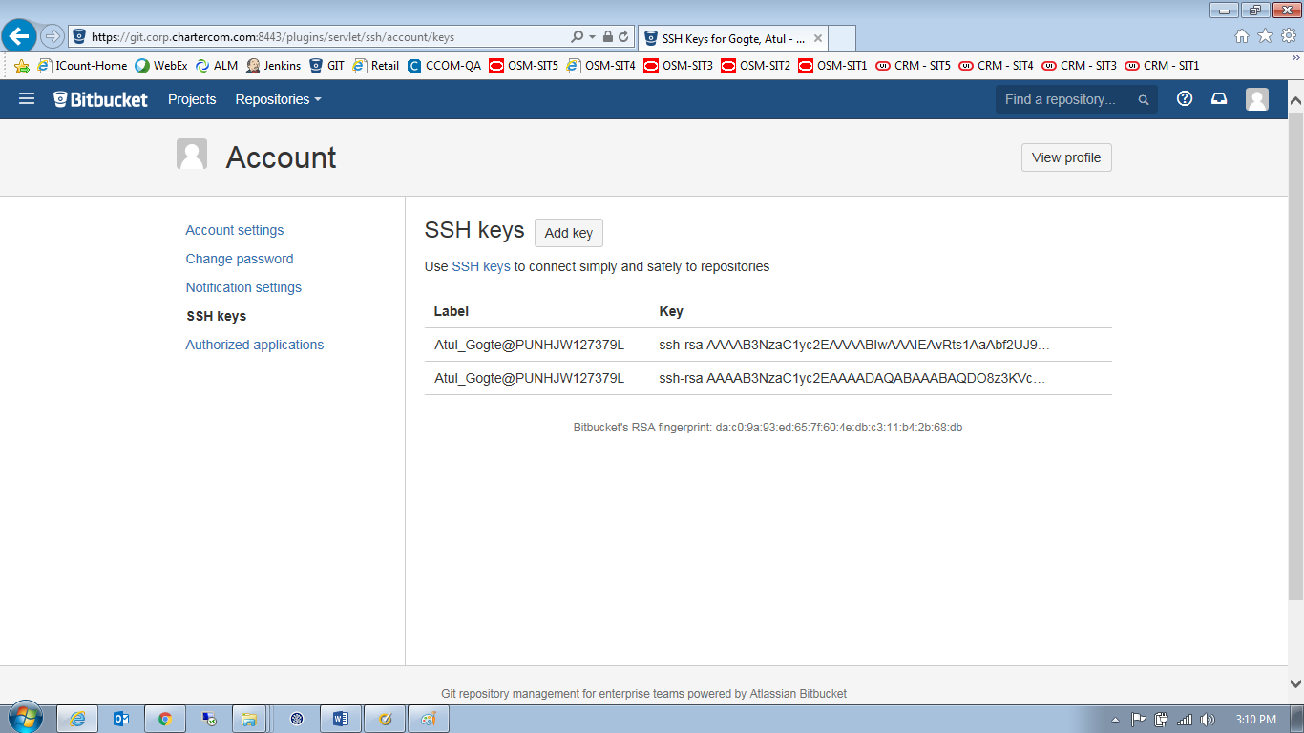

Step 4 - Access the bit bucket using the SSH URL

Now you can access/create/clone bit bucket repositories using the SSH URL

Format of the SSH URL is as follows

**ssh://<userid>@<bitbucket server name>:<port>/<project name>/<repository name>.git**

Userid = PID

Bit bucket server = git.corp.chartercom.com

Port = 7999

Project = TAF (framework project) or TAA (Application project)

Repository name = Framework or Ecommerce or Gateway etc..

Working Example of SSH URL

**ssh://P2248342@git.corp.chartercom.com:7999/TAF/Framework.git**

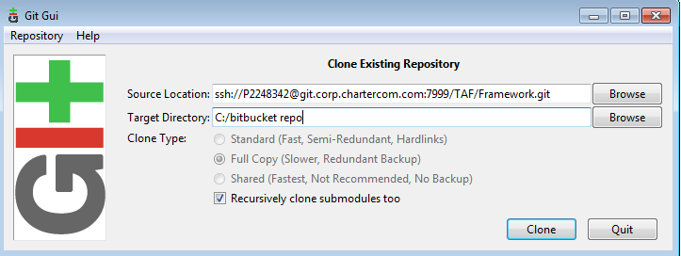

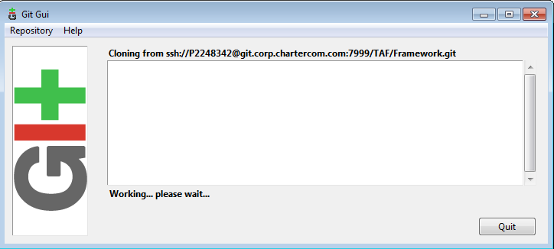

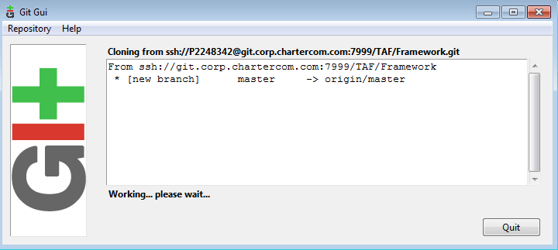

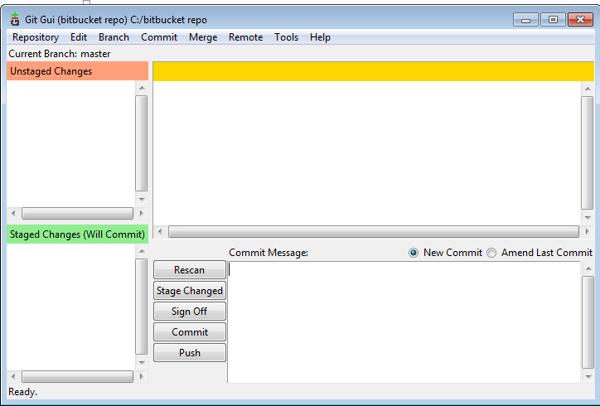

You can see your bit bucket repository is successfully cloned onto your local machine

